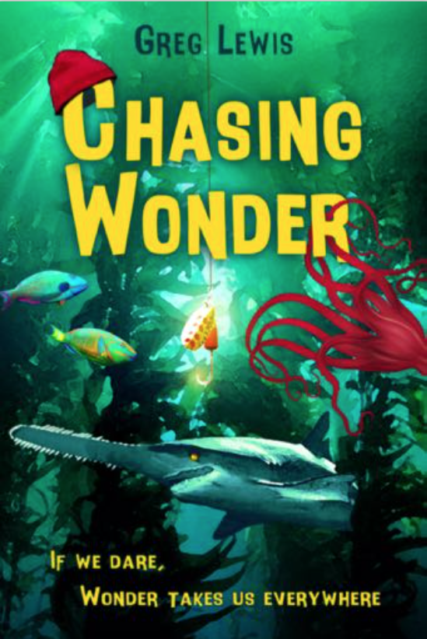

Digital Guided Unit Plan for Chasing Wonder

Why Students Should Read Chasing Wonder

Chasing Wonder is a poetic tale that seamlessly embraces ideals that underpin character and social-emotional well-being. Author Greg Lewis has created a protagonist all students (all people) can connect with when they struggle to make personal decisions that will lead them out of their place of comfort and into a place of authenticity.

While the novel is rich with literary and written standards, it is the story’s lessons of self-worth that make it most notable. Chasing Wonder explores the core experiences of life that forge our being: peer pressure; bullying; trust; faith; determination; friendship; kindness; failure; fear; loyalty; truth.

Wonder lights a path toward personal and worldly wisdom. Chasing Wonder invites everyone to make and enjoy the journey.

The Teacher’s Unit Plan encourages a deep read into the individual stanzas, inspiring self-awareness, self-management, social awareness, responsible decision-making, and relationship skills.

~Lianne Markus, Middle School Language Arts and SEL Teacher: K-6 Elementary Gen Ed, K-12 English
~Jennifer Encin, Middle School Language Arts Teacher: K-12 English

Instructions for ACCESSING Google Forms
1. Both you and your students will need to have Google accounts (which are free).
A Google account grants access to Google Drive, where Google Docs, Sheets, Slides and Forms are housed.
This product is a Google Form but results can also be exported to Google Sheets.

2. Click on a link and on blue button that says Make a Copy.

4. Clicking on that link will create your own copy of the product (Google form).
The Google form will be saved in Google Drive.
This Google form will open.

Instructions for USING Google Forms
1. Share only in a password protected platform or in Google Classroom using the link.

2. Remind students it is VERY important that they answer the 1st 2 questions: “What is your first name?” and “What is your last name?” (Separating these questions allows you to sort by last name when scores are exported to Sheets.)

3. Students will complete multiple choice and open-ended questions as part of the Google form. At completion, they will be able to see their score but it won’t include open-ended questions. You will need to score those individually.

4. When students finish, go to your copy of the form in Google Drive.
• At the top, click on “Responses.” There are three categories there.
*SUMMARY provides a summary of student scores and responses.
*QUESTION provides a breakdown of student answers by question.
*INDIVIDUAL shows responses for each student. You can click through, one by one on the top right, to the left of the printer icon. You will use this option to score open-ended responses, using score input arrows to the right of each question.

5. After scoring, open-ended responses, you can create a spreadsheet using the green and white Sheets icon in the top right corner. It looks like this:
• This spreadsheet will automatically save to your Google Drive. There will also be a brief option that appears in the bottom left saying “open spreadsheet.”
• It will also update automatically as other students take this quiz. If you use this product with multiple classes or year after year, you will want to make additional copies to avoid having all responses recorded in the same place.



Note: All Google Forms and Documents can be printed for classroom use only.

Common Core Standards:
http://www.corestandards.org/ELA-Literacy/

Key Ideas and Details:
CCSS.ELA-LITERACY.RL.1
Cite textual evidence to support analysis of what the text says explicitly as well as inferences drawn from the text.
CCSS.ELA-LITERACY.RL.2
Determine a theme or central idea of a text and how it is conveyed through particular details; provide a summary of the text distinct from personal opinions or judgments.
CCSS.ELA-LITERACY.RL.3
Describe how a particular story's or drama's plot unfolds in a series of episodes as well as how the characters respond or change as the plot moves toward a resolution.

Craft and Structure:
CCSS.ELA-LITERACY.RL.4
Determine the meaning of words and phrases as they are used in a text, including figurative and connotative meanings; analyze the impact of a specific word choice on meaning and tone
CCSS.ELA-LITERACY.RL.5
Analyze how a particular sentence, chapter, scene, or stanza fits into the overall structure of a text and contributes to the development of the theme, setting, or plot.
CCSS.ELA-LITERACY.RL.6
Explain how an author develops the point of view of the narrator or speaker in a text.
CCSS.ELA-LITERACY.RL.7
Compare and contrast the experience of reading a story, drama, or poem to listening to or viewing an audio, video, or live version of the text, including contrasting what they "see" and "hear" when reading the text to what they perceive when they listen or watch.

Range of Reading and Level of Text Complexity:
CCSS.ELA-LITERACY.RL.10
By the end of the year, read and comprehend literature, including stories, dramas, and poems, in the grades 6-8 text complexity band proficiently, with scaffolding as needed at the high end of the range.

Chasing Wonder Anticipatory Guide

Anticipatory Google Slide Deck Activity | “The Walrus and The Carpenter” by Lewis Carroll | Discussion of what is a narrative novel. Introduction of Chasing Wonder.

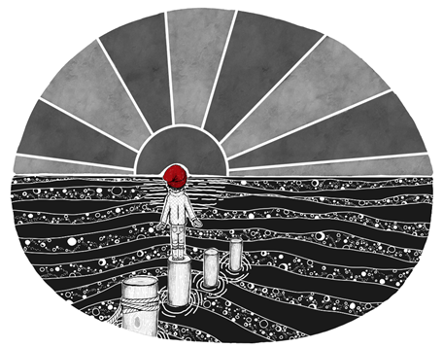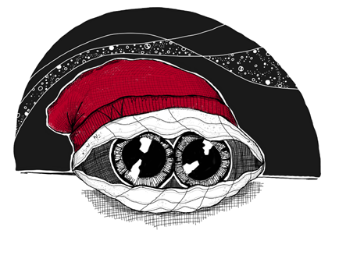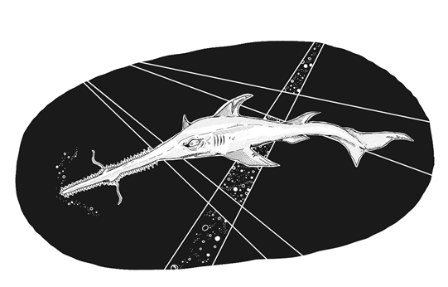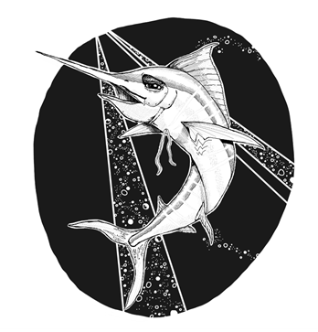

For audio links, click here: Chasing Wonder Audio ; Song Lyrics; Discussion Points for Musical Composition

Chapter/Title: Anticipatory Set - Gallery Walk | Time: 45 minutes

Learning Objectives:
Activate prior knowledge.
Explore multiple resources. (5 mins. per station x 7 stations)
Using their Wonder & Note chart (Slide 2), students will predict what the book, Chasing Wonder, will be about.

Assessment: Informal Evaluation - Teacher will circulate to ensure students are making sufficient effort to participate.

Materials:
Timer
Copies of Wonder & Note chart (Slide 2) for each student
Station #1: Chromebook (headphones or earbuds)
Station #2: Copies of Carroll’s “The Walrus and the Carpenter”
Chromebook
Station #3: Chromebook
Station #4: Chromebook
Station #5: Chromebook (headphones or earbuds), salt water, various seashells, beach sand
Station #6: Dictionary or Chromebook
Station #7: Chromebook

Instructional Procedure:
Students will circulate between stations completing each task and/or responding to each prompt on their Wonder & Note chart in the allotted time.
Prompts can be found on this GOOGLE SLIDE DECK.

Chapter/Title: Prologue  “The Walrus and the Carpenter” by Lewis Carroll | Time: 45 minutes

Materials:
Copies of “The Walrus and The Carpenter” by Lewis Carroll (Print and Audio linked HERE.)
Edpuzzle by Amy Winterbottom linked HERE
Exit Ticket linked HERE

Learning Objectives:
Define “narrative poem.”
Identify a prologue and its purpose.
Analyze how a particular stanza fits into the structure of the text and contributes to the development of setting and/or plot. (RL 5)

Formative Assessment:
Edpuzzle or Responses to Text-Dependent Questions
Informal Assessment/Exit Ticket: Students will independently respond to the question.
Infer why Greg Lewis used this specific stanza from “The Walrus and The Carpenter” as the prologue to his book.
The eldest Oyster looked at him,
But never a word he said:
The eldest Oyster winked his eye,
An shook his heavy head --
Meaning to say he did not choose
To leave the oyster-bed.
- “The Walrus and The Carpenter” by Lewis Carroll 1872
Should be revisited again after reading Chasing Wonder.

Bell Ringers/Journal Prompts:
Can a piece of writing be BOTH a poem and a story? Explain why or why not.
OR
The word “prologue” comes from the Greek word “prologos” which is a combination of two roots “pro” and “logos.”
Using what you know about Greek roots and their meaning, what is the meaning of the word “prologue”?
Check your definition against the definition in the dictionary.

Comprehension and Analysis Lesson
- Teacher will introduce narrative poems.
A narrative poem is a poem that tells a story. It contains all of the elements of poetry such as rhyme and sound devices but also includes narrative elements such as setting, characters, and plot.

- Introduce “The Walrus and The Carpenter” by Lewis Carroll and have students read through the text independently.

- Students will actively listen as the teacher reads the narrative poem or plays audio recording.

- Teachers and students will reread text analyzing the poem through the use of text-dependent questions. (EdPuzzle linked HERE.)

- Teacher will introduce the purpose of a prologue and discuss what Chasing Wonder might focus on.
“A prologue is a literary device that rouses the reader’s interests and provides a hint of what’s to come. A prologue performs one of many functions in a story: foreshadowing events to come, providing background information or a backstory on the central conflict, establishing the point of view, or setting the tone for the rest of the book” (Writing 101: How to Write a Prologue Written by Masterclass/Dan Brown November 8, 2020).

- Complete exit ticket.

Chasing Wonder
Chapters 1-4

Rhyme Scheme | Vocabulary/Word Meaning/Tone | Allusions

Chapter/Title: Chapters 1-4: Sea For Yourself; It’s All About Hattitude; Veni Vidi Vici; Discovery | Time: According to student needs and expectations.

Learning Objectives:
To identify the text’s rhyme scheme and structure.
Determine the meaning of words and phrases as they are used in a text, including figurative and connotative meanings; analyze the impact of a specific word choice on meaning and tone.
To identify an allusion and interpret the figure of speech in context.

Assessment:
Lesson 1: Vocabulary Quiz (Google Forms)
- Chapter 1 Vocabulary Quiz
- Chapter 2 Vocabulary Quiz
- Chapter 3 Vocabulary Quiz
- Chapter 4 Vocabulary Quiz
Lesson 2: Comprehension Quiz (Google Forms)
Lesson 3: Allusion Activity will be assessed using a rubric

Bell Ringers/Journal Prompts:
Chapter 1 - “Wonder is the beginning of wisdom.” - Socrates How does this quote apply to you as a learner? Write for 5 minutes.
Chapter 2 - Show students photographs of a red chapeau, a deerstalker, a stovepipe hat, and a coonskin cap. Who famously wore these hats? Hattitudes
Chapter 3 - In the first stanza, Lewis writes, “The unknown can be a frightening thing, Open to wild imagining.” What are the positive and negative aspects of “the unknown”? Write for 5 minutes.
Chapter 4 - What limiting beliefs do you have that keep you from reaching a goal or a dream? Write for 5 minutes.

Vocabulary:
Lesson 1
Pre-teach vocabulary. Have the students look up the meaning and part of speech for each of the vocabulary words. After reading the individual chapter, have the student re-read the stanza with the specific word, interpret the meaning of the word, and discuss word choice, tone, and mood where applicable. (Students should keep a vocabulary notebook to record words throughout the novel.)

Chapter 1 - vastness, confined, contentment, resentment, chapeau, perched, nomad
Chasing Wonder Vocabulary Chapter 1 Google Form
Chapter 2 - merit, squall, wanderlust, recede, dangling participle, apogee, couture
Chasing Wonder Vocabulary Chapter 2 Google Form
Chapter 3 - aberration, deviation, sinister
Chasing Wonder Vocabulary Chapter 3 Google Form
Chapter 4 - banish, fluke, toque, promenade, opus, sentry, ingenue, milieu, groupies
Chasing Wonder Vocabulary Chapter 4 Google Form

Sound Devices/Word Choice/Figurative Language:
Lesson 2
Rhyme Scheme/Personification/Word Choice

Identify and interpret the meaning of personification/word choice as a class discussion. Students could always be encouraged to illustrate the figurative element.

Personification
Chapter 1
Curiosity, you’ll quickly realize
Strip all things of their disguise.
Wonder ensures an amazing ride

Chapter 2
On that day strange winds began to blow
And a twisting squall sept very low
Its greedy hands reached way down
To grab all things loose around

And then that fateful random gust
Alive with airborne wanderlust
Carried the tiny cap across the sky
As if that bright red cap could fly

Word Choice
Chapter 1
They’re tied in “knots” in all they do

Chapter 2
A maze of currents in constant flow

Chapter 3
And whatever is mysterious
Can trigger blinding fear in us

Chapter 4
Even a nearby sand dollar knew that made no cents
To be.. To be… or not to be

Comprehension and Analysis:
Lesson 3
Comprehension
Comprehension Quiz for Chapters 1-4 linked HERE.

Analysis
Allusion (To be completed after reading Chapter 4)
1. Teacher will divide the class into four groups.
2. Assign an allusion to each group and using the internet, have each group research the backstory or original story.
3. Student groups will record the original story and the comparison on a Google Slide.
4. Lastly, students can evaluate the effectiveness of their assigned allusion.
Chapter 1 -“a distinctive knit chapeau, Bright red and stylish, as chapeaus go” - Jacque Cousteau
Chapter 2 - “maddest hatter” - Alice in Wonderland by Lewis Carroll
Chapter 3 - “Vendi, Vidi, Vici” and “A mighty Roman emperor of very long ago, A legendary general whom none could ever slow” - Julius Caesar
Chapter 4 - “I guess it’s up to me, To be...to be… or not to be” - Hamlet by William Shakespeare.
- “While a nearby starfish marched in place, to an anthem quite star-spangled” - “The Star-Spangled Banner” by Francis Scott Key
Exit Ticket

RUBRIC FOR ALLUSION ACTIVITY
Standard | Not Met Standard/Not Included | Met Standard | Exceed Standard
Origin/original story of the allusion is included.
The author may have chosen to use this allusion to convey their story.
An evaluation of effectiveness is included

Cross Curricular Activities for Chapters 1-4:
Music: NY Times How to Study Literature through Music
Writing: If you had to compare your life to a famous piece of literature or historical event, what would it be and why?
Science: The Billion Oyster Project; Noise Pollution Hurting Oysters
Art: Research The Great Wave off Kanagawa by Katsushika Housai/ The Great Wave Art Project published by Deep Space Sparkle
World Culture: Readworks.orgThe Knysna Oyster Festival

Chasing Wonder
Chapters 5-7

Compare/Contrast | Identify and Interpret | Classifying Conflicts

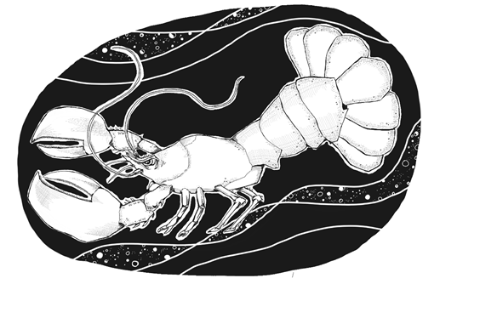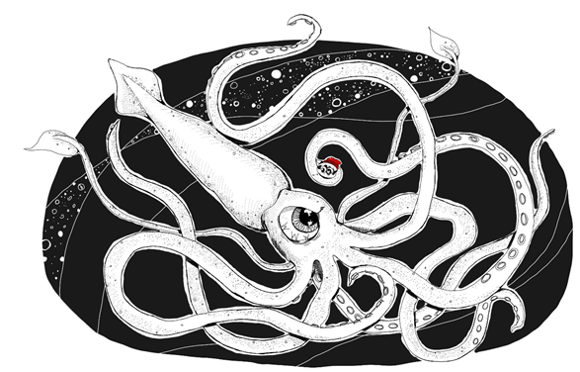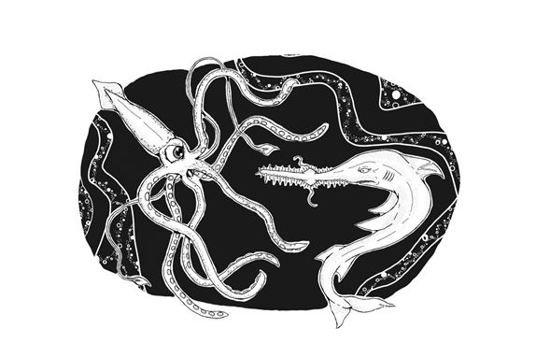
For audio links, click here: Chasing Wonder Audi; Song Lyrics; Discussion Points for Musical Composition

Chapter/Title: Chapters 5-7 Esteemed Lobster, Rock & Roil, The Sawfish and The Squid | Time: According to student needs and expectations.

Learning Objective:
Compare and contrast the experience of reading the poem to listening to the text, including contrasting what they "see" and "hear" when reading the text to what they perceive when they listen
Determine the meaning of words.
Identify and interpret figurative language and word play.
Classify conflicts found in the text by type. Analyze what traits the conflict reveals about the character.

Assessment:
Lesson 1: Vocabulary Quiz (Google Forms)
Chasing Wonder Vocabulary Chapter 5 Google Form
Chasing Wonder Vocabulary Chapter 6 Google Form
Chasing Wonder Vocabulary Chapter 7 Google Form
Lesson 3: Types of Conflict Matching Activity
Comprehension Quiz (Google Form)

Bell Ringers/Journal Prompts:
Chapters 5, 6, 7: There are hidden and visible W’s in the artwork. Chapter 5 has 9 Ws; Chapter 6 has 3 Ws; Chapter 7 has 4 W’s. Can you find them all?

Vocabulary:
Lesson 1
Pre-teach vocabulary. Have the students look up the meaning and part of speech for each of the vocabulary words. After reading the individual chapter, have the student re-read the stanza with the specific word, interpret the meaning of the word, and discuss word choice, tone, and mood where applicable. (Students should keep a vocabulary notebook to record words throughout the novel.)

Chapter 5: esteemed, harkened, posterior, queasy, resistance, vidi
Chapter 6: roil, grim, lurking, ricocheted, bleak, demise,contemplating, liberating, pro quo
Chapter 7: boast,snarling,phalanxes,smirk, bravado, apropos, undaunted

When complete, students will be partnered to play a game of Chasing Wonder Battleship.
Vocabulary Battleship

Word Choice/Figurative Language:
Lesson 2
Audio Chapter 5
After listening to Chapter 5, students will be asked to illustrate the event. Then students should read the chapter and compare and contrast what they "heard" and "saw".

Comprehension and Analysis:
Lesson 3
Comprehension
Comprehension Quiz for Chapters 5-7 linked HERE.
Answer Key:
- The struggle between two opposing forces
- See below
- Active during the night
- All (physical description, dialogue, actions, thoughts and feelings and thoughts and feelings of others)
- The lobster’s color matched his personality.
- The sawfish Vidi is lurking nearby
- Answers will vary. Students might infer that at this point the oyster would not have ventured out. Words such as “resistance” and “too afraid” support this inference.
- Answers will vary.
- Answers will vary. “Gigantic oyster,” “Pressed against the squid’s hard beak,” “Right below his bulging eyes,” “Black in white and so outsized”
- “Let the buyer beware”
- The flashback informs the reader how Vidi’s fin was mutilated by the shark and the details behind the deal Vidi struck with Squid Pro Quo.
- Answers will vary. Students might infer that he is clever or conniving.

Types of Conflict (To be completed after reading Chapter 7)
1. Introduce conflicts and provide everyday examples that students would be familiar with. (a disagreement with a friend, not having enough money to purchase a video game, bad hair day, etc.)
2. Introduce literary conflicts.
A literary conflict results from two opposing forces in a story.
Four common types of conflict are:
Character vs. Self—a character experiences conflict between forces within him/herself
Character vs. Character—a character experiences a conflict with another character
Character vs. Nature—a character struggles to overcome forces of nature
Character vs. Society—a character struggles with elements of his/her society such as established rules or traditions
3. Reread page 18 to the first stanza on the top on page 19. Identify and discuss the conflicts. (Example: Chapter 4, 6th stanza)
4. Students will independently complete the matching activity linked HERE.
5. Analyze and discuss what the conflicts reveal about each of the characters.

Exit Ticket

Cross Curricular Extension Activities for Chapters 5-7
Writing:: Do you, or have you had, “a lobster, sawfish, or squid” in your life? Write an essay that explains how each one affected or changed you.
Science: Ocean Animal Encyclopedia Have students research a specific marine animal and create a trifold that highlights specific topics. Host a school community invite where attendees can go from student stations to listen to presentations.

Chasing Wonder
Chapters 8 - 12

Author’s Craft | Characterization | Reader’s Theater
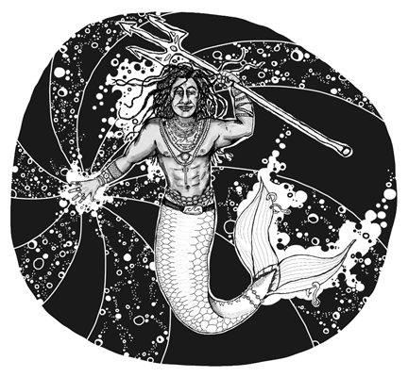
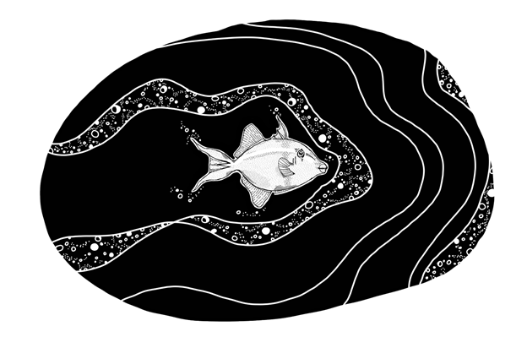
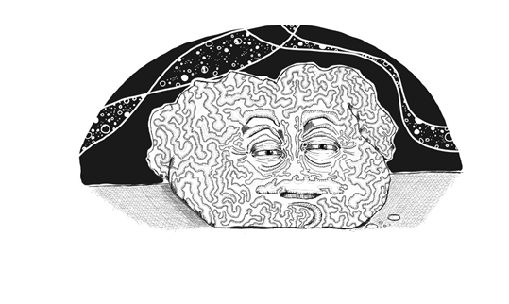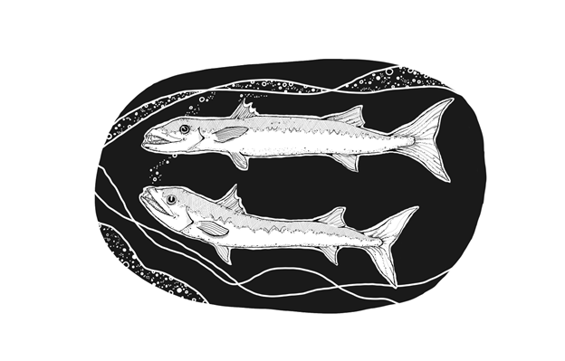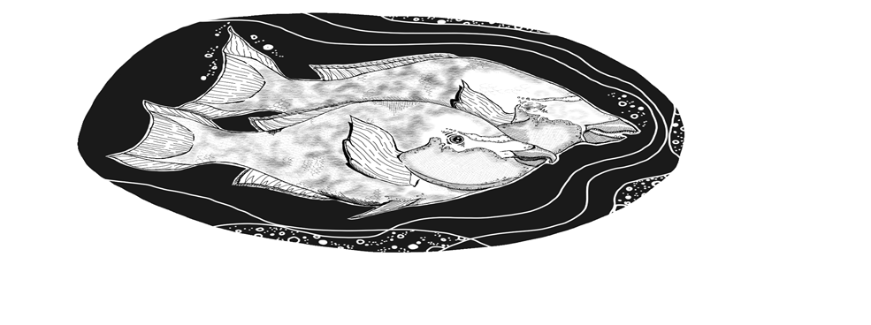
For audio links, click here: Chasing Wonder Audio; Song Lyrics; Discussion Points for Musical Composition

Chapter/Title: Chapters 8-12 Wonderful; Au Pair of Fish; Size Matters; Sound Advice; Tuning In | Time: According to student needs and expectations.

Learning Objectives:
Author’s craft. Word choice/meaning.
Identify types of characters.
Analyze how particular lines of dialogue reveal aspects of a character, provoke a decision, or propel the action/sequence of events.
Compose and perform a script that examines the influences of characters on the protagonist.

Assessment:
Chasing Wonder Vocabulary Chapter 8 Google Form
Chasing Wonder Vocabulary Chapter 9 Google Form
Chasing Wonder Vocabulary Chapter 10 Google Form
Chasing Wonder Vocabulary Chapter 11 Google Form
Chasing Wonder Vocabulary Chapter 12 Google Form
Chasing Wonder Character Analysis Chart
Role-Play Rubric
Exit Ticket

Bell Ringers/Journal Prompts:
Chapter 8: What do the following words have in common: “Ja, Da, Oui, Si”?
Chapter 9: Choose a character trait that begins with the letter listed for Oyster. Jamboard - Character Traits for Oyster
Chapter 10: Did you know the Polynesian alphabet only has 12 letters? How do you think that will relate to this chapter considering the title?
Chapter 11: Using only letters, write a message to your classmates.
Chapter 12: Use figurative language to describe the deepest part of the ocean.

Cross Curricular Anticipatory Activities:
Writing: In the beginning of Chapter 8, the oyster drifted to The Great Barrier Reef and saw various types of coral (elephant coral, pillar coral, table coral, fan coral, staghorns, and brain coral). Have students select a type of coral to research and write an I Am Poem from the point of view of a piece of coral.
Link to the Great Barrier Reef Marine Park Authority
Science: On page 35, Coral Larry says, “Like inconvenient truths - Al Gore-isms.” Have students do a quick internet search on the Oscar winning documentary An Inconvenient Truth. Set a purpose for reading. What is the connection? How does this help the reader better understand the author’s tone?
Art: Watch the National Geographic video clip linked here. The Great Barrier Reef Next, create a coral sculpture using recycled materials.
World Culture: These chapters discuss both Australia and Hawaii. Conduct short research on the fishing industries of these places and how it contributes to their economy. Create a Google Slide, or a script read into Screencastify, for presentation.

Vocabulary:
Lesson 1
Pre-teach vocabulary. Have the students look up the meaning and part of speech for each of the vocabulary words. After reading the individual chapter, have the student re-read the stanza with the specific word, interpret the meaning of the word, and discuss word choice, tone, and mood where applicable. (Students should keep a vocabulary notebook to record words throughout the novel.)

Chapter 8: coral anemones, benighted, erudite, blundered, elusive
Chapter 9: unrelenting, dereliction, cacciatore, famished, gluttonous, serendipity
Chapter 10: humuhumunukunukuapua'a, passive, accrue, transcends, revered
Chapter 11: bemused, gnawing, staccato, uttered, ennui, intoned, inanity, paradox
Chapter 12: trident, crude, lore, galleons, diluted, exalted, myriad
Complete Vocabulary Choice Board to study the words.

Word Choice/Author’s Craft:
Lesson 2

Chapter 8
The author makes several references to the oyster’s journal including - The Great Barrier Reef comprises all types of coral; And happy fish that seldom quarrel. And, in quoting Hamlet, “We know what we are, but know not what we may be.” What connection is the author making to the story of the oyster?

After reading, have the students discuss the difference between knowledge and wisdom. Then, ask the students to write down five pieces of wisdom. Have them share the one that relates to a personal life experience. Wisdom is gained from a lesson learned.

Have students go back through the chapter and find the pieces of wisdom that the oyster was given by Coral Larry.

Chapter 9
Read the play on words in stanza 11. Why did the author craft the words as such?

Chapter 10
Know Truth wears no disguise
No Truth means only lies

Look at the use of the words, “Know” and “No”. Why did the author choose them? What is the deeper meaning of this stanza?

Chapter 11
Read stanza 14. Why did the author choose the word “whitewash”?

Why did the author name the parrot fish Yada Yada and Blah, Blah, Blah?

Chapter 12
Read stanza 3, line 1. Why did the author print NepTune as such?

Comprehension and Analysis:
Lesson 3
Comprehension Assessment for Chapters 8-12 linked HERE.
- Allusion
- Wonder
- Answers will vary. (have a purpose, be open-minded, live life, feel alive, do it all, don’t just survive; wonder, question, admire and be curious;seel all the wisdom, never stop learning,)
- Serendipity is defined as the occurrence and development of events by chance in a happy or beneficial way. Text evidence to support the meaning: “And sometimes we just happen to be--, here and there to do some good, And we’d do more, if we could, But it’s all by chance; we never know, We can’t be everywhere you might go!” OR “As good fortune is never here to stay.”
- They have both been left out or disliked.
- Go and inform Vidi of the oyster’s whereabouts.
- Answers will vary. YadaYada and Blah Blah Blah are shallow or superficial and focus on their looks. They lack understanding and insight.
- Twain acts like an older brother and encourages and gives him advice - “Be careful where you sail your thoughts.”
- Answers will vary. Students may infer that even though the majority of the chapter focuses on NepTune, describing him as powerful, mesmerizing, strong, that Vidi, “the one with the darkest of histories,” was unyielding leaving the ocean and NepTune disturbed.

Character Analysis
PART 1:
The Character Analysis Chart is linked HERE.
- Introduce Types of Characters:
  - Protagonist - the central character in a story who is often referred to as the main character. He or she is faced with a conflict that must be resolved.
  - Flat - a flat character demonstrates one kind of personality trait or characteristic.
  - Round - a rounded character is anyone who has a complex personality and is more fully developed in the story.
  - Dynamic - a dynamic character is someone who changes over time usually after resolving a conflict.
  - Static - a static character is someone who does not change over time; his or her personality stays the same.
- Students will complete a chart indicating if the characters are flat/round and dynamic/static.
- Introduce the 5 methods of character development:
  - Physical Description
  - Dialogue
  - Actions
  - Thoughts and feelings of the protagonist
  - Thoughts and feelings of the other characters
- Students will add evidence from the text to support a selected character trait.
- Students will determine their motive(s) and if each character’s role in Wonder’s journey is positive or negative citing evidence to support their conclusion.

PART 2:
- In groups of 2 or 3, students will use the text and their analysis of the characters to compose a script of each interaction. (It may be helpful to discuss the elements that need to be added when “translating” poetry into a script: description of scene, stage directions that focus on body language and facial expressions, dialogue, props/costumes, etc.)
  - Group 1: Wonder and Coral Larry
  - Group 2: Wonder, Sara and Dipity
  - Group 3: Wonder and Humuhumunukunukuapua’a
  - Group 4: Wonder, YadaYada and BlahBlahBlah
  - Group 5: Wonder and Twain
- Groups will “perform” their script in front of the class. After each skit, the class will discuss how each of the characters influenced Wonder. During the role-play, are students able to demonstrate how each character influences Wonder?

Exit Ticket

RUBRIC FOR ROLE-PLAY ACTIVITY
Standard | Not Met Standard/Not Included | Met Standard | Exceed Standard
Participation | Unfocused during group work and presentation, | Willing and focused during group work and presentation. | Always willing and focused during group work and presentation.
Presentation of Characters | Limited number details about the character’s thoughts/feelings and motives were included. | Sufficient number of details about the character’s thoughts/feelings and motives were included. | Convincing communication of the character’s thoughts/feelings and motives were included and clearly explained.
Are students able to demonstrate how each character influences Wonder? | Script vaguely addresses the characters’ influence. | Script clearly addressed the characters’ influence. | Script effectively addressed and highlighted the characters’ influence.
Creativity | Choices demonstrate little awareness and do little to enhance the text. | Choices demonstrate thoughtfulness and enhance the text. | Choices demonstrate insight and effectively enhance the text.

Cross Curricular Activities for Chapters 13-17:
Writing: Personal narrative. Write about a time someone gave you advice that you learned was a truth.
Science: Attend a virtual field trip. Seattle Aquarium
Art: Serendipity in Art

Chasing Wonder
Chapters 13-17

Irony | Citing Evidence | Word Meaning
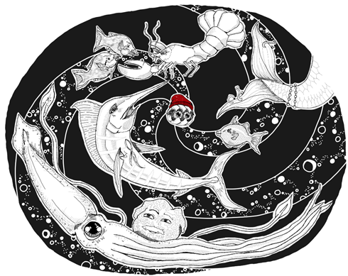 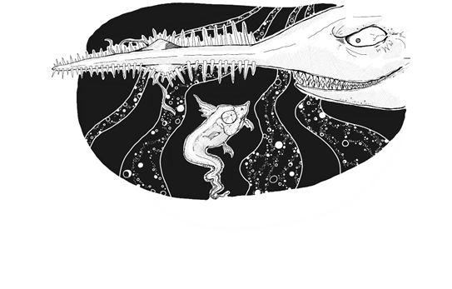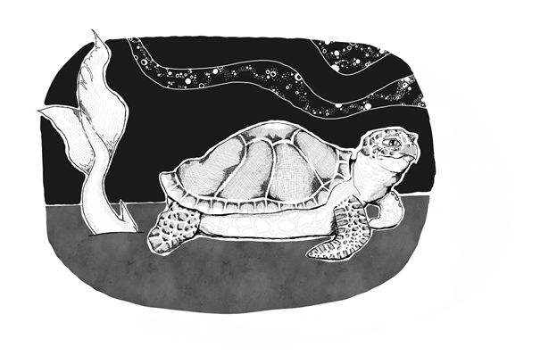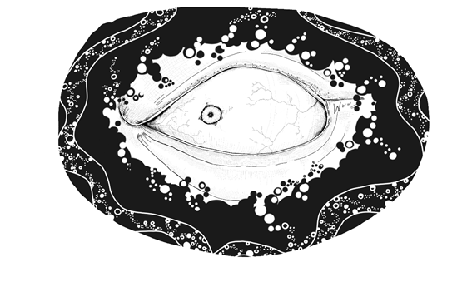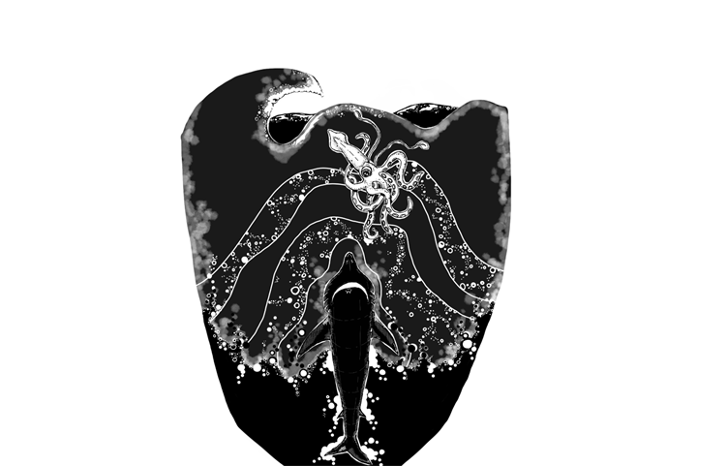For audio links, click here: Chasing Wonder Audio; Song Lyrics; Discussion Points for Musical Composition

Chapter/Title:Chapters 13-17 Rhyme or Reason; Hurry Up and Ate; Guess Who’s Coming to Dinner; Me, Myself, and Eye; Rising to the Occasion | Time: According to student needs and expectations.

Learning Objectives:
Identify and define the 3 types of irony.
Cite and explain the example of irony.
Determine the meaning of words.
Cite evidence to support findings.

Assessment:
Comprehension Assessment for Chapters 13-17
Create a kidblog discussion. Students will be asked to create a blog post that uses 10 of the vocab words in summarizing these chapters. Peers will be asked to respond to one post and use a vocabulary word in their response.

Bell Ringers/Journal Prompts:
Chapter 13: What does the idiom “Rhyme or Reason” mean?
Visit the Blue Planet Aquarium’s website and read about why turtles move so slowly.
Chapter 14: Watch the following video clip and discuss Finding Nemo Irony Scene
Chapter 15: Journal Prompt: Think of a time when you planned something and everything went wrong. Write for 5 minutes.
Chapter 16: Look up the history of the phrase “Hurry Up and Wait.” How does it apply to the events of Chapter 14?
Chapter 17: What is the depth of the deepest ocean? Can you guess? (Mariana Trench, Pacific Ocean. Approx. 7 miles)

Vocabulary:
Lesson 1

Pre-teach vocabulary. Have the students look up the meaning and part of speech for each of the vocabulary words. After reading the individual chapter, have the student re-read the stanza with the specific word, interpret the meaning of the word, and discuss word choice, tone, and mood where applicable. (Students should keep a vocabulary notebook to record words throughout the novel.)

Chapter 13/14: undulating, conspicuous, astute, soiree, smirking, recklessly, haste, apocalypse, irony
Chapter 15: predation, Twain, Murphy’s Law, serene, contorted, lament, malcontent
Chapter 16: emitted, uncouth, brawn, honed, contrived, extricate, gambit, surreptitiously
Chapter 17: ravenous, cavernous, treason, adversary, vertigo
Quizlet Flashcards

Symbolism/Inference
Lesson 2
“What’s in a name?” ~Shakespeare

Comprehension and Analysis:
Lesson 3
Comprehension Assessment for Chapters 13-17 linked HERE.
Answer Key
1. The last line on page 62 reveals that Squid Pro Quo made a deal with Coral Larry for a ride to the reunion.
2. Vidi ate him.
3. After he arrived, Vidi hid “beneath a hump of sand.”
4. Anything that can go wrong will go wrong.
5. Twain rested his “poundage” on top of Vidi.
6. To get Twain to move, Vidi burps.
7. Twain had heard a rumor that Vidi was out to get Wonder, and that caused him to worry.
8. In Chapter 16, the reader learns that Squid Pro Quo manipulated the situation causing Wonder to get stuck so that he can save and then trick him.
9. NepTune invited a humongous shark.
10. Her job is to “sift through the sea’s dishonesty.

Analysis: Irony
- Introduce the three types of irony and provide a real world example of each.
- Verbal irony - when the character says one thing but means the exact opposite. (Coming to school really early but realizing you forgot your homework. “I guess today is my lucky day.”)
- Situational Irony - when the opposite of the expected occurs. (A fire at the firehouse.) * Be sure to highlight that coincidences are not examples of irony.
- Dramatic Irony - when the character believes something and the opposite is true. (Here the audience is more aware than the character.) An evil queen tries to hide her identity as an old witch, but the audience knows her true identity.
- View the video Learn Irony Types Using Movie Clips linked HERE and discuss the examples of irony.
0:50 - Verbal irony
1:24 - Situational irony
3:18 - Dramatic irony
- Point out the last line on page 66 “I, Ronnie.”
- Have students independently identify an example of irony in Chapter 14, label it verbal, situational, or dramatic, and explain how they came to their conclusion.
Answer: Students should identify Ronnie Rattail’s death as an example of situational irony. The readers expected Vidi to revel in the information Ronnie was going to provide about Wonder’s whereabouts and did not expect for him to eat him.
- Discuss: What does this reveal about Vidi’s character?

Exit Ticket

Play Booklet: Types of Irony
Play Kahoot: Types of Irony

Cross Curricular Activities for Chapters 13-17:
Writing: Research the history of your name and the meaning. Is there a reason your parents named you as they did?
Science: Smithsonian Educators Lesson Plans on Oceans
Art: Draw a life-size whale on pavement.
World Culture:
Math: Draw a life-size whale on pavement using precise measurements.
Technology: Create a podcast that retells one of the chapters from the point of view of one of the characters. Create a podcast!

Chasing Wonder
Chapters 18-21

Tone | Mood | Plot Structure

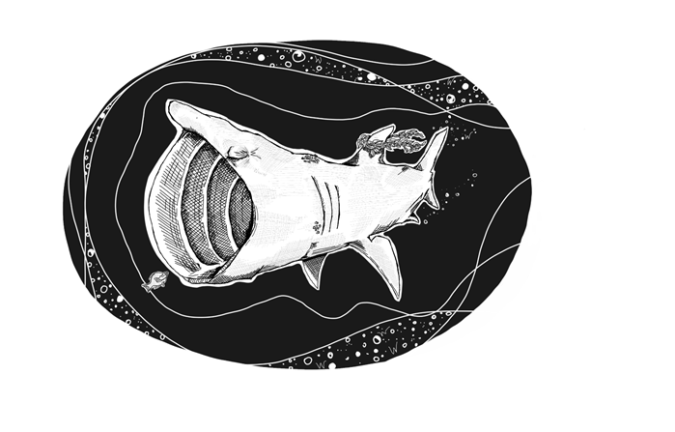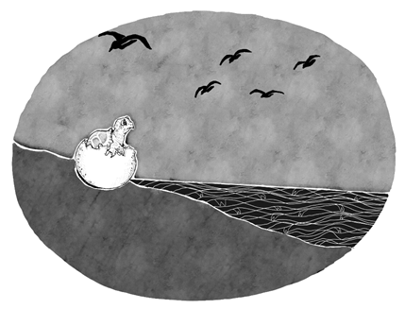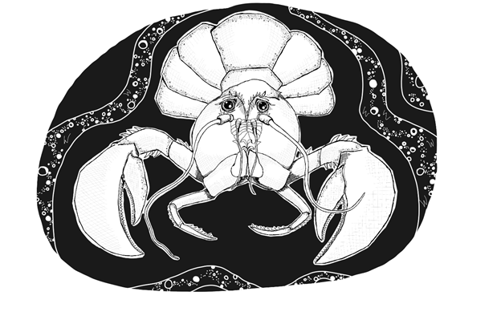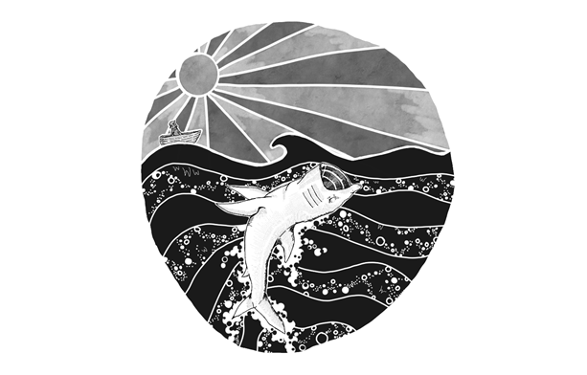
For audio links, click here: Chasing Wonder Audio; Song Lyrics; Discussion Points for Musical Composition

Chapter/Title: Chapter 18-21  Big MawMaw; Shore Enough; Jealous Sea; Proph-O-Seas | Time: According to student needs and expectations.

Learning Objectives:
Determine the meaning of words.
Determine tone and mood.
Cite evidence to support findings.
Demonstrate an understanding of the stages of plot by applying knowledge and completing a plot diagram/pyramid.

Assessment:
Vocabulary Quiz: Vocabulary Quiz Chapters 18-21
Listen to David Melton’s musical compositions of one of the Chapters. Describe the mood using descriptive language.
Then re-read the chapter and identify the author’s tone. Support your claim with evidence from the text. (dialogue, characters, scenes, music)

Bell Ringers/Journal Prompts:
Chapter 18: It’s What’s on the Inside that Matters - activity.
Introduce the concept of a backstory - is a comprehensive overview of a character's history that extends beyond the story in which the character appears.
Chapter 19: Watch a video on the hatching of sea turtles. Other than the bird, what other risk factors/obstacles might the sea turtles have to face in order to hatch and make it safely to the sea?
Chapter 20: Quickwrite: Have you ever been jealous of someone? If so, explain why.
Chapter 21: Using Jamboard, have students share the best piece of wisdom that has ever been given to them. Jamboard Link

Vocabulary:
Lesson 1
Pre-teach vocabulary. Have the students look up the meaning and part of speech for each of the vocabulary words. After reading the individual chapter, have the student re-read the stanza with the specific word, interpret the meaning of the word, and discuss word choice, tone, and mood where applicable. (Students should keep a vocabulary notebook to record words throughout the novel.)

Chapter 18: detrimental, perplexed,contrived, boasted
Chapter 19: unwittingly, consoled, derided, platitude
Chapter 20: ensued,repressed, disdain, lore
Chapter 21: conundrum, ubiquity, perspicacious, mendacious, befuddled, quandary

Sound Device/Figurative Language:
Lesson 2
Mood Definition and Example
Tone Definition and Example

Read the poem “The Road Not Taken” by Robert Frost. When finished, open a discussion on the following question:
What is the mood and tone of the poem? The Road Not Taken

Partner work:
- Choose three of the following movie clips to watch.
- When completed, describe the mood and tone using descriptive language.
- Analyze your evidence by explaining what parts of the movie clips had you choose the word. (dialogue, characters, scenes, music)

Mary Poppins Trailer
Forrest Gump Movie Trailer
Elf Movie Trailer
Frozen Movie Trailer
Toy Story 3 Movie Trailer
The Shining Movie Trailer

Comprehension and Analysis:
Comprehension Assessment for Chapters 18-21 is linked HERE.
Answer Key
- Alliteration
- Answers will vary.
- A backstory is a comprehensive overview of a character's history that extends beyond the story in which the character appears
- Answers will vary. Twain’s message is that we should live our lives fully for ourselves and in honor of those whose lives were cut short. Don’t dwell on things you cannot change. Live.
- Guilt
- Crusher became a bully “to get even and be rough, just to show them he was tough.”
- think deeply about something; meditate or reflect
- All of the above.
- Idiom
- Cliffhanger

Lesson 3
Plot
- Teacher will review the phrase “narrative poem.” A narrative poem is a poem that tells a story. It contains all of the elements of poetry such as rhyme and sound devices but also includes narrative elements such as setting, characters, and plot.
- Teacher will review the stages in the narrative arc of Freytag’s Pyramid including exposition, inciting incident, rising action, climax falling action, resolution, and denouement.
- Review the characteristics of a plot. Chasing Wonder is told in chronological order, however, it will be helpful to discuss the differences between significant events and other events in the poem as well as the connection between the plot and the conflicts in the poem.
- Students will identify the stages of plot using events from Chasing Wonder and complete Jamboard activity linked HERE.

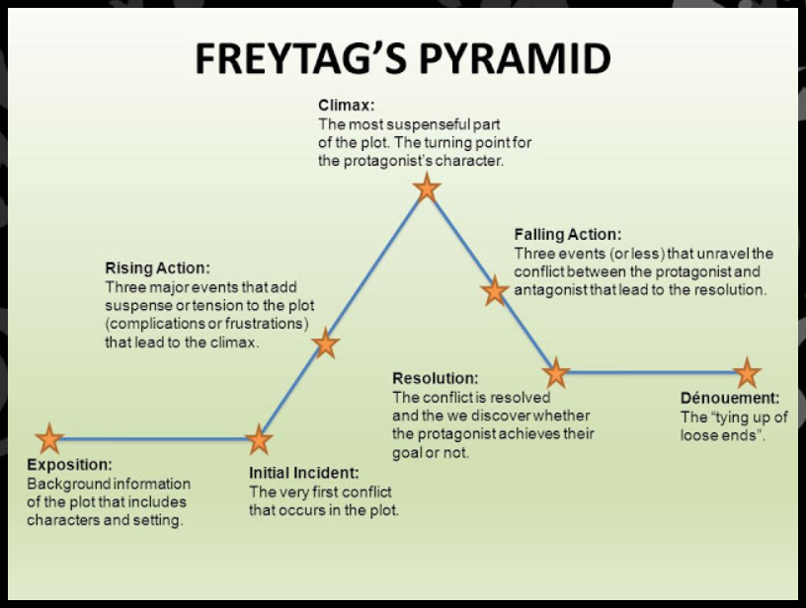

Cross Curricular Activities for Chapters 18-21:
Science: PBS Learning/Lesson Plans: How Inventions are Saving Sea Turtles or seeTURTLES Lesson Plans
Art: Mood and Tone from Melton’s musical composition.
World Culture/Writing: Research the teachings of Confucius and Socrates. Write a compare/contrast on the teachings of Confucius to Socrates.
Math: Track a sea turtle and answer the following questions: How many miles did the trip cover? What was the average speed from fix to fix and for the entire trip? What was the heading (compass direction) on each leg of the trip? Calculate total distance traveled, straight line distance, average daily distance, average daily speed. Satellite Tracking of Sea Turtles
Technology: Create a timeline of your life’s events in Google Slides.

Chasing Wonder
Chapters 22-24

Speaking/Listening | Structure | Theme

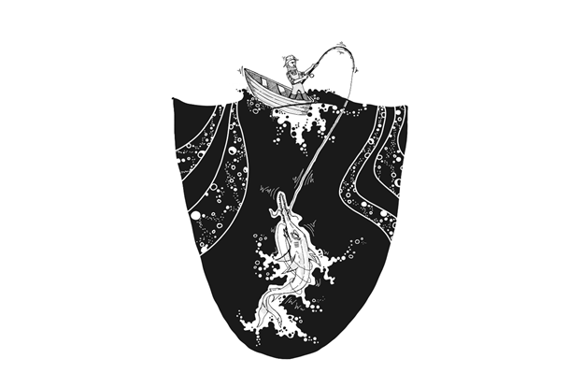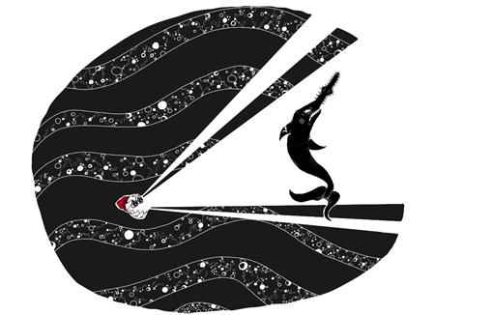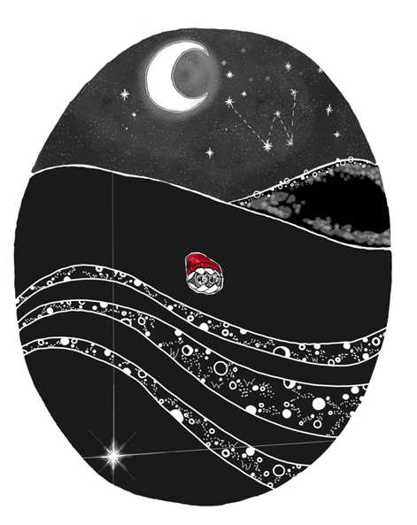
For audio links, click here: Chasing Wonder Audio; Song Lyrics; Discussion Points for Musical Composition

Chapter/Title: Chapter 22-24  Ups and Downs, The Roar of The Ocean, Sea the Light | Time: According to student needs and expectations.

Learning Objectives:
Determine meaning of words.
Cite evidence to support findings.
Determine the theme of a story using details from the text.
Analyze how a particular stanza fits into the overall structure of a text and contributes to the development of the theme.

Assessment: Comprehension Quiz (Google Form)
Thematic Statement (supported with textual evidence)
Summative Writing Assignment

Bell Ringers/Journal Prompts:
Chapter 22: Sketch what you think a Sawfish looks like.
Chapter 23: Examine the illustration on page 111 focusing on light and dark.
Chapter 24: Quick Write: What does this quote mean to you? “Life is a sum of all your choices” ~Albert Camus

Vocabulary:
Lesson 1
Pre-teach vocabulary. Have the students look up the meaning and part of speech for each of the vocabulary words. After reading the individual chapter, have the student re-read the stanza with the specific word, interpret the meaning of the word, and discuss word choice, tone, and mood where applicable. (Students should keep a vocabulary notebook to record words throughout the novel.)
Chapter 22: malevolent, augured, surreal, depravity, loathing
Chapter 23: existential, enmity, denouement, introspection, reverential, trepidation,luminescent, tableau,

Analyze a stanza and determine how it contributes to the theme.
Lesson 2
Chapter 23 Re-read stanza 6. Discussion Point: How does this stanza relate to the author’s message?
Chapter 24 Re-read stanza 7. Discussion Point: What message does the author present regarding wonder having a pearl? How does this relate to the theme?

Comprehension and Analysis:
Comprehension Assessment for Chapters 22-24 linked HERE.
- Rhyme
- Sara and Dipidee grabbed the fisherman’s line causing Vidi to become entangled and forcing the hook into his lip.
- Alliteration
- True
- According to the text, when one is fearful, he/she should take time and make a prudent action plan.
- The 6 ideals are noted on page 113: Truth is always most essential, Beauty makes you reverential, Goodness leaves you feeling great, Justice for all must never wait, Equality belongs to everyone, and Freedom’s quest is never done.
- When Wonder opens his shell, a luminescent pearl is dislodged.
- Assonance (line,time)

Lesson 3
Theme
- Teacher will introduce the concepts of “topic” and “theme.” Review common topics found in literature emphasizing that topics are 1-word subjects about the reading (love, friendship, honesty, etc.) Then discuss themes highlighting that themes are sentences that highlight the author’s message to the reader and are more broad, profound, and meaningful to the reader than topics.
- Teachers will lead students in identifying topics that reflect big ideas in Chapters 22-24. Collect student responses on chart paper/board.
- Themes can be identified by examining how the characters change throughout the story. In this case, looking to see how Wonder reacts to various situations will reveal clues about the themes of Chasing Wonder.
Questions to ask:
  - How did Wonder react to obstacles?
  - What important decisions did Wonder make in Chapters 22-24?
  - How did Wonder grow and change over the course of the story?
  - What did Wonder learn?
- Students will select a topic and compose a thematic statement and cite evidence from the text to support their claim. Comparing the main theme of Chasing Wonder to other stories, such as The Sea Glass Treasure by Shelly Peters, will enhance students’ understanding of themes being broad and universal.

Summative Assessment: Students will compose an alternate ending to the story and then analyze whether or not the new ending affects the story’s themes.

Cross Curricular Activities for Chapters 22 - 24:
Science: PBS Learning/Lesson Plans: Refraction experiments
Art: Use art such as Edvard Munch’s The Scream which will inspire a discussion about themes on fear and uncertainty.
Music: Songs can lend themselves to a discussion of how artists communicate larger messages (themes) through lyrics. For instance, Lee Ann Womack’s “I Hope You Dance” lends itself to a discussion of independence.

Pearls of Wisdom From author, Greg Lewis.

- Wonder. It’s what we all should do. Admire. Let Curiosity through.
- If you wonder, then it’s wonder you’ll find. Awe and beauty of a staggering kind.
- Feeling alive is what you want to feel. So get out there; go be real.
- Who you are is your spirit, not your shell. It’s your ideas and what you do well.
- Fill your world with gratitude. Embrace a positive attitude.
- You only get to do this once. Get smart; don’t be a dunce.
- Know Truth wears no disguise. No Truth means only lies.
- Beauty becomes really true only when it’s through and through… every little bit of you.
- Even if you look, doesn’t mean you see. Blindness is its darkest when “I” deceives “me”.
- Don’t burden your mind with the past and the future, at long last!
- Be careful where you sail your thoughts. Don’t anchor in a paradox.
- Just do what’s best. Avoid the rest.
- Nothing stays the same forever; no matter how hard you may endeavor.
- Power over others doesn’t make wrong things right. Especially if that power is based on fright.
- Truth is always most essential. Beauty makes you reverential.
- Goodness leaves you feeling great. Justice for all must never wait.
- Equality belongs to everyone. Freedom’s quest is never done.
- There’s nothing wrong with squid pro quo. If it’s a fair deal, it’s good to go.

Q&A with author, Greg Lewis
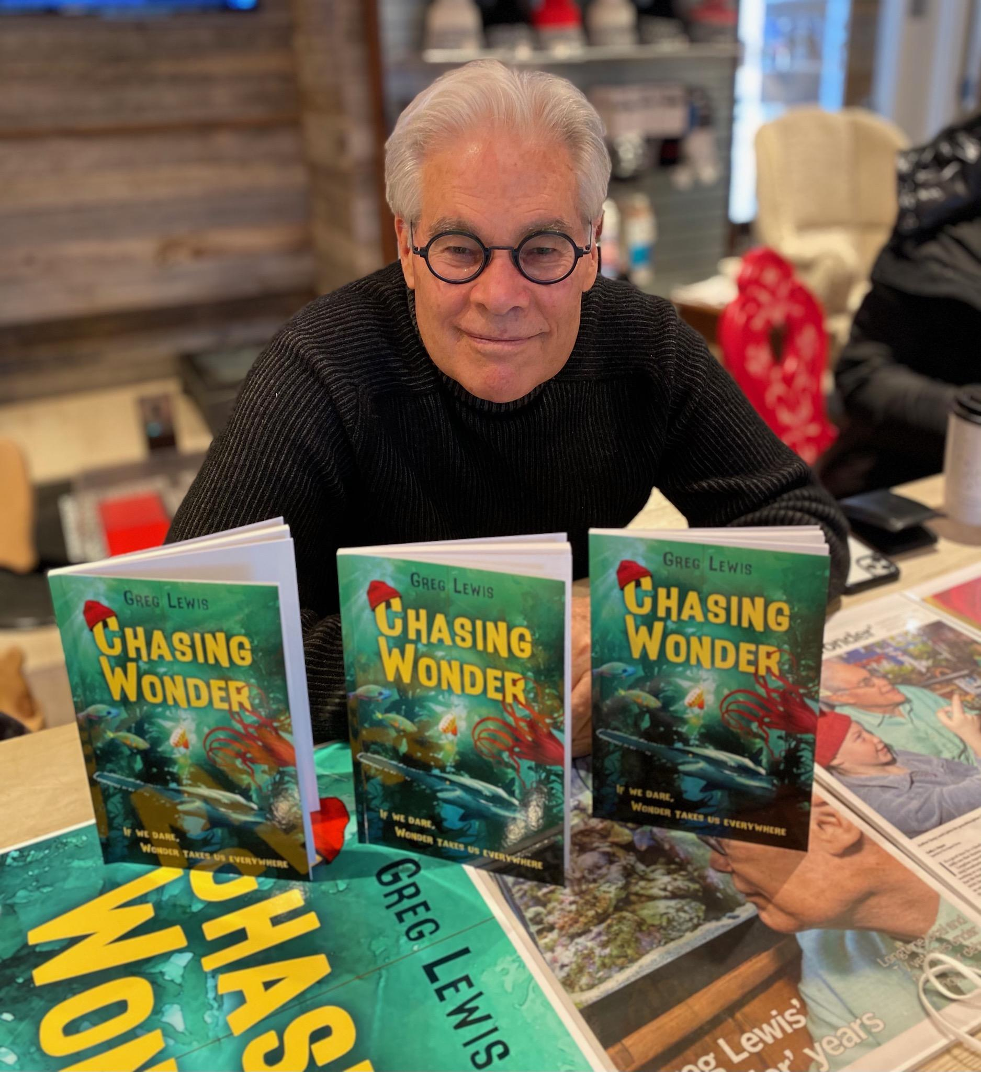
Is Chasing Wonder based on your life experiences?
In many ways, yes. I have been a certified scuba diver for almost 40 years, so my diving experiences have informed my awareness of various forms of sea life and activity. The advantage to a story that’s set in the oceans is that it is timeless. The sea as it is today is the way it will be a century from now (in general). But experiences I have had that didn’t occur under water also informed the story. My ideals and values, the references to science and philosophy and literature—everything I know from 73 years of living shaped the messages in Chasing Wonder.

Why Jacques Cousteau?
In an initial concept of the story, the oyster was going to leave the oyster bed on his own, because he was bored and, at the same time envious, of all the sea life that he observed. The oyster’s name at that point, seven years ago when I started writing, was called Jacques Gusto. Look up Gusto. But everything changed, and I ended up writing a very different story. Nonetheless, a red cap, which Cousteau usually wore, became a way to make the oyster different and distinctive and to set his odyssey in motion.

Did Legs, Legs, Legs start a new chapter for you?
As a result of the success of Legs, Legs, Legs, I received an EMMY award for writing. That’s an honor that opens a lot of doors to new, bigger and better assignments and opportunities. Legs changed my life in numerous ways.

What’s your favorite book? What book are you reading now?
My favorite book is Grapes of Wrath by John Steinbeck. For me, it is the “Great American Novel.” The Great Gatsby, by F. Scott Fitzgerald, is the most common pick for the “Great American novel,” but not for me. Usually, I am reading several books concurrently. I am reading a collection of poems by the most recent Nobel Prize for Literature recipient. I’m reading a book by a long-deceased Swiss author named Stefan Zweig. And I read books on various subjects that interest me, such as philosophy and history. I can read these intermittently because each chapter is standalone, as a magazine article is.

What’s your favorite activity to do in your free time?
I live in the mountains of Colorado, in a town called Aspen. I am happiest in nature, whether riding my bike, hiking or skiing. I have been skiing for 67 years.

When did you learn that you can write poetry?
I’m not sure I can identify a specific time. I read Dr. Seuss as a child. I love Robert Frost. One of the most meaningful and prophetic pieces of writing I know is William Butler Yeats “The Second Coming.” I write prose, as well, but poetry is a beautiful challenge, especially if you want the poem to follow a rhyme pattern or meter. Rhymes and poetry are a puzzle to solve. How to say what you want to say in a language that is completely fresh, that is evocative, rich and also lean. I think a great poem reveals itself further each time it is read. I differentiate between rhyme and poetry. Most of Chasing Wonder rhymes. Some is poetry:
And then he gazed into the distance
Beyond time and place and his resistance
Might the oyster get stuck inside low tide
Too afraid to explore the other side
Past the edge where what’s known ends
Where courage and confidence are your best friends

Why did you choose to write your book in poetry? Did you ever think “I should be writing this differently”?
When I started writing, I envisioned a short story in simple rhyme. Rhyme, I thought, would be fun and could be clever and memorable because it had a tempo and could be lyrical. It’s easier to remember the words in a song than it is to remember the words in an essay. By the time the story took on a life of its own, there was so much rhyme already constructed that I decided to continue in rhyme. At one point I did attempt to convert it to prose, but prose fell short of the poetic or rhyming voice.

Did you have specific experiences that inspired you to write Chasing Wonder?
Not necessarily, but the entire story builds toward a stanza about Truth, Beauty, Goodness, Justice, Equality, Freedom. Those are the ideals I hold most precious.

Are there characters in the book that are from real people in your life?
Only Vidi, and he is a composite of the traits and beliefs of the worst people I have known in my life.

If you had to compare yourself to a sea creature, which one would you like?
Ah, an interesting question that I have not considered until now. Probably a porpoise, perhaps a sea turtle like Twain. Maybe Moby Dick.

What do you hope the reader takes away from your book?
Don’t get stuck in the past. Don’t let inertia keep you from moving forward. Good judgement will take you farther than expedient judgement. Keep moving, exploring, being. Engage in life, live it. Be in the now. Everything I need to know I have learned from two lines of Shakespeare: To be or not to be. To thine own self be true. In other words, decide to live life to its fullest, and you will not succeed if you are not self-aware and be who you are. Don’t become a lawyer if you really want to be a school teacher.

Who is your favorite character and why?
Big MawMaw. She is everyone’s conscience. Everything she does is intended to be good and result in self-awareness. She enables each of the characters to look into themselves and gain understanding. Big MawMaw has soul, compassion, wisdom, caring… grace.

Have you met any famous athletes?
Many. For 30 years, 35 weeks a year, I covered sporting events around the world. I met renowned champions in many sports, including the Olympics. Champions are people with talent and grit—and indefatigable resolve. My answer to the next question will tell you more.

What was your favorite experience with an athlete or while covering sports?
I covered Olympic diving in 1988 in Seoul, Korea. The world’s greatest diver at that time was Greg Louganis, who won two gold medals in the previous Olympics and was competing for two more. He won the three-meter springboard, so he had one more event to win, the 10-meter platform, which means diving from 33 feet above the pool, like leaping off a three-story building into water. The competitors make several dives. Greg was trailing by a significant margin after every dive, to a young Chinese diver named Jong Ni. Greg made the final dive of the competition, a very difficult dive that he had to perform perfectly. So, his dream of a fourth gold medal, the goal of his life, up to that point, came down to performing perfectly on a single dive—fewer than two seconds in the air. In other words, at that time, the meaning of his life, all he had done—the work, the determination, the sacrifice, the world’s expectations—was distilled down to the last two seconds of his career. What do you think happened?
I am fascinated by a person’s ability to be the best they can possibly be, to deliver when everything is on the line in a situation where the world is watching. After the scores flashed and it was apparent Greg had won, the producer asked me to go to a commercial. I said, “With a leap of faith, Greg Louganis spins air and water into gold.” In everyone’s life there are moments when you must make a leap of faith or be stuck. Reread the stanza about “low tide,” above.

How old were you when you first started writing poetry?
Probably younger than ten, but simple rhymes. The dog and the hog swam in the bog.
How long did it take you to write, edit and then publish Chasing Wonder?
Seven years. 2,000 hours. It was a labor of love. Good writing isn’t written, it’s rewritten. Some of the stanzas, six lines, took four hours to write.

What was your inspiration behind choosing an oyster as your main character?
An oyster is non-descript. It doesn’t venture from where it is born. It is simple. And we can’t see what’s inside. I describe all the other characters in the book, but never really reveal anything about the oyster. He becomes what he experiences, as a result of wonder. And oysters produce pearls as a result of a piece of sand that gets in their shell. In other words, good comes out of bad.

Thank you for your purchase of this unit plan.
If you have any questions, you can email us at lewiswonder64@gmail.com

Credits:
Madison, Michael. “ 5 Minute Countdown - Underwater.” YouTube, uploaded by Micahel Madison, 10 Jan. 2016, https://www.youtube.com/watch?v=pp1EZ0xQSmE&t=4s

MacIntyre, Christopher. “The Walrus and the Carpenter by Lewis Carroll Read by Roy Macready.” YouTube, uploaded by Christowpher MacIntyre, 24 March, 2015, https://www.youtube.com/watch?v=2CWOp5cqA10&t=6s

RealLifeLore. “The Ocean is Way Deeper Than You Think.” YouTube, uploaded by RealLifeLore. 11 November 2016.https://youtu.be/GE-lAftuQgc

Relaxing White Noise. “Ocean Waves Relaxation 10 Hours | Soothing Waves Crashing on Beach | White Noise for Sleep.” YouTube, uploaded by Relaxing White Noise. 10 July 2016. https://youtu.be/WHPEKLQID4U
Carroll, Lewis. “The Walrus and the Carpenter by Lewis Carroll.” Poetry Foundation, Poetry Foundation, www.poetryfoundation.org/poems/43914/the-walrus-and-the-carpenter-56d222cbc80a9
“The Great Wave Art Project.” Deep Space Sparkle, 21 May 2020, www.deepspacesparkle.com/the-great-wave-art-project/.
David Melton. “Songs of Wonder.” CDBaby, 2021. 23, June 2021. https://davidmelton.hearnow.com/

Blue Planet Aquarium. “Turtles Myths about its Slowness.” Aspro Parks, 2021 23, June 2021. https://www.blueplanetaquarium.com/blog/sea-life/turtles-myth-about-slowness/

bhershey78. “NEMO_Simming Out to Sea.dv.” YouTube, uploaded by bhershey78, 20 July 2010, https://www.youtube.com/watch?v=9RhX3lRJQMg

Reproduction Live TV. “Baby Sea Turtle Hatching.” YouTube, uploaded by Reproduction Live TV, 5 March 2019, https://www.youtube.com/watch?v=YbsBO3Cg2ug

MrGay. “Tone & Mood Mary Poppins Movie Trailer).” SchoolTube, uploaded by Mr.Gay, 25 August, 2019, https://www.schooltube.com/media/Tone+%26+Mood+%28Mary+Poppins+trailer%29/1_oltvkcu1
MovieClips Trailers. “Forrest Gump 20th Anniversary IMAX Re-Release Trailer (2014) - Tom Hanks Movie HD.” YouTube, uploaded by MovieClips Trailers, 29 July, 2014, https://www.youtube.com/watch?v=Wc8GlIT1ZzU

MovieClips Classic Trailers. “Elf (2003) Official Trailer #1 - Will Ferrell, Zooey Deschanel Christmas Movie HD.” YouTube, uploaded by MovieClips Classic Trailers, 28, November, 2012, https://www.youtube.com/watch?v=gW9wRNqQ_P8

MovieClips Trailers. “Frozen Official Elsa Trailer (2013) - Disney Animated Movie HD.” YouTube, uploaded by MovieClips Trailers, 17, October, 2013, https://www.youtube.com/watch?v=FLzfXQSPBOg&list=PLzFz35PAA7-eYBkaaVcV5jGmUcMUL9cL4

Stanley Kubrick. “The Shining - Official Trailer [1980] HD.” YouTube, uploaded by Stanley Kubrick, 6, April 2012, https://www.youtube.com/watch?v=S014oGZiSdI&list=PLzFz35PAA7-eYBkaaVcV5jGmUcMUL9cL4&index=4
“Freytag's Pyramid: A Postdoc's Story of Transitioning to Professor.” URBEST Blog - Graduate Education & Postdoctoral Affairs - Education - University of Rochester Medical Center, ww.urmc.rochester.edu/education/graduate/ur-best-blog/july-2018/freytag%E2%80%99s-pyramid-a-postdoc%E2%80%99s-story-of-transitioni.aspx.
ClipArt and Font Credits:


